Dual Credit Courses

Students interested in Dual Credit classes need to select Dual Credit during registration.

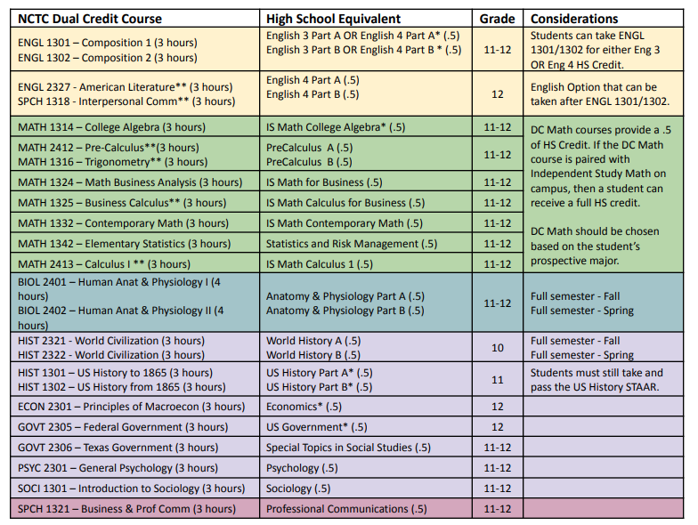

*Course is offered on FMHS campus.

**Course requires a prerequisite.

★ Courses are taken through North Central Texas College (NCTC), with course availability offered at the college campus, online, or at MHS home campus.

★ Courses are offered through the Summer, Fall and Spring semesters.

★ 3 college hours are equivalent to .5 high school credit upon successful completion of the course (unless otherwise stated by NCTC).

★ Dual Credit grades will average in the GPA (English, Math, Science, and Social Studies).

★ Multiplier for Dual Credit courses is 1.2

★ Students must APPLY and be accepted to NCTC.

**Students/Parents are responsible for all registration, tuition, fees, NCTC deadlines, and textbook costs.**